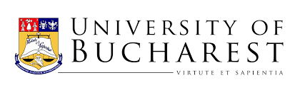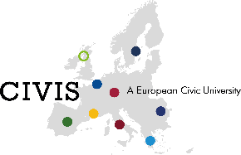

Microprograme CIVIS – oferta comună (mai 2021)
Universitatea din București și Universitatea din Tubingen

Cursurile oferite de Universitatea din București
- Norms, Values and Action. Issues in Moral and Practical Philosophy
- Riparian zones: waste areas or assets for biodiversity and human wellbeing?
- University-based projects for local sustainable development: Implementing the UNESCO Geoparks Program in Romania
- Social Change through Marketing and Leadership
- Engaging marginalized communities
- Inclusive University – an important step towards an inclusive society
- Chemistry Solutions‬ for Global Challenges
- Eco-friendly Technologies for Energy Conversion and Storage
- Physicists as civic scientists
- Minorities, Equity and Community Development
Cursurile oferite de Universitatea din Tubingen
- Global Migration Politics and Realities
- Actively shaping the city
- Engagement Transfer
- Integrations-Mentoring – „Wir – gemeinsam für Integration“
- Democracy and Digitalization: An Introduction to Theories and Debates
- Common Ground despite Controversy: Creating a Digital Network
- Digitales Buddy-Programm: Tübingen - Virtual Intercultural Pre-Package (Tü-VIPP)
- Engagement in Student Initiatives
- ROCK YOUR LIFE! Tübingen e. V.
- Transnational Labor Governance and the Digital Transformation
- Defining Sinti and Roma as Migrants
- Working as a Musician in Tübingen – Mapping Musicians’ Field of Work
- Working as Musicians in the World – Snap-Shots
- Diversity in Global Christianity and Judaism
- Challenges of Microfinance in International Development Cooperation
- Quel monde pour demain?
- Round Table
- Global Issues

