DUNE, the international experiment for the study of neutrino physics, in which a UB team is involved, has reached a new milestone

The DUNE project - Deep Underground Neutrino Experiment, an international experiment dedicated to the study of neutrino interactions and proton disintegration, has announced new information on its progress: 800.000 tons of rock were dislodged to make room for the installation of detectors which will allow scientists to identify new sub-atomic phenomena and to transform the potential to understand neutrinos and their role in the Universe.

Over 1400 researchers from more than 200 institutions in 35 countries (+ CERN) are involved in the DUNE project, among which a group of professors and students from the Faculty of Physics of the University of Bucharest, as well as specialists from the European center for Nuclear Research - CERN from Geneva. The UB team is represented by professors Ionel Lazanu, PhD, and Alexandru Jipa, PhD, lecturers Mihaela Pârvu, PhD, and Marius Călin, PhD, PhD student Ioana Lalau and Masters’ student Denis Barbu.

Thus, 2024 marks the completion of subterranean excavations for the Long-Baseline Neutrino Facility (LBNF) in Lead, South Dakota. At the same time, the setup of subterranean spaces will start soon, preparing the way for installing DUNE detectors. This enterprise will help us find answers for more fundamental questions on the nature of matter and the evolution of universe: the origin of matter, the asymmetry between matter and antimatter after Big-Bang, the unifying of forces and the formation of black holes.
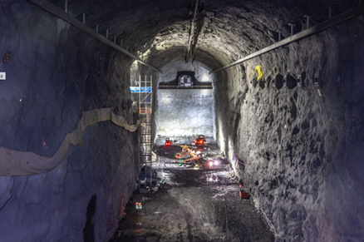
Photo: Matthew Kapust, Sanford Underground Research Facility

The 4 neutrino detectors will be installed in these subterranean spaces, each having approximately 66 x 19 x 18 m³ ⁻ the equivalent of a 7 storey building. The detectors will be filled with 70.000 tons of liquid argon and will register interactions of neutrinos.

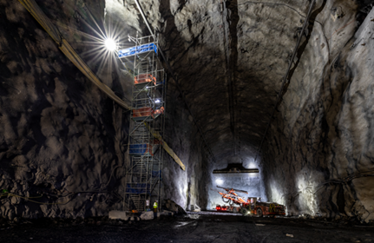
Photography: Matthew Kapust, Sanford Underground Research Facility

Thus, the DUNE project will use the neutrinos to obtain answers to as many of these open questions of modern physics as possible. Trillions of neutrinos flow through our body each second, without us even knowing. The DUNE detector is also capable to register the neutrinos produced in star explosions such as supernovas. Researchers will examine the behavior of a fascicle of neutrinos produced by Fermilab, in the proximity of Chicago, situated approximately 1300 km away from these subterranean spaces.

The DUNE team hopes that the first neutrino detector will be functional before the end of 2028.
The DUNE collaboration is coordinated by Mary Bishai, researcher at Brookhaven National Laboratory and Sergio Bertolucci, Physics professor at the University of Bologna. The entire organizing structure is a consortium with work-groups and committees to ensure the proper functioning and implementation of activities, developing detectors, prototypes and the efficient coordination of the relation between DUNE and LBNF, on one side, and CERN, on the other side.
More on the DUNE project - Deep Underground Neutrino Experiment is available here.

