Discussions on the attitudes regarding vaccination, with professor Cosima Rughiniș and PhD student Diana Moga, in a new episode of the SKEPSIS series

In the 6th episode of the SKEPSIS series, professor Cosima Rughiniș, PhD, teaching staff at the Faculty of Sociology and Social Work of the University of Bucharest, and PhD student Diana Moga from the UB Doctoral School in Sociology, propose a discussion on the attitudes regarding vaccinations.

What are the main causes of the skepticism regarding vaccination, both in Romania, as well as in other countries?
Vaccination has become a very controversial subject in many parts of the world, and debates related to this theme are intense. Thus, in today’s episode of SKEPSIS, professor Cosima Rughiniș, PhD, invites us to better understand the way in which attitudes regarding vaccination are constructed in society. Are controversies around this subject recent, influenced by the Covid-19 pandemic? Or are they older? At the same time, what historical moments have influenced attitudes regarding vaccination?

What are the main causes of the skepticism regarding vaccination?
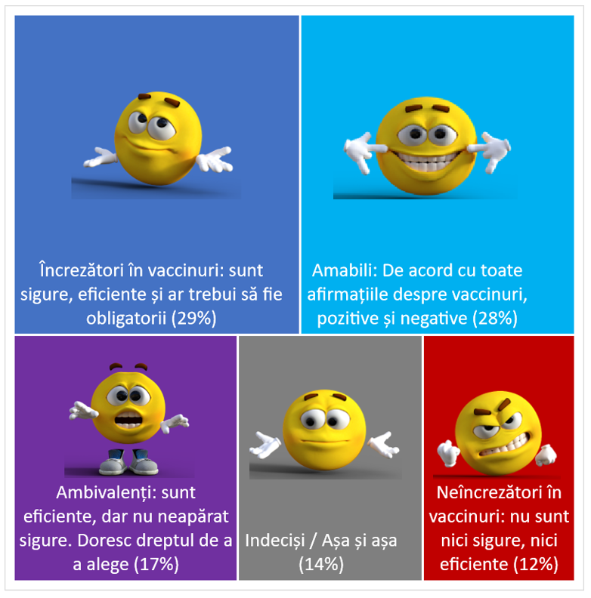
Also, in today’s episode we will find out the arguments that people who are hesitant or skeptical about vaccination bring forth, and also how social media and the internet influence the attitudes regarding vaccination. Finally, professor Cosima Rughiniș and doctoral student Diana Moga discuss the public policies that could combat the skepticism associated with vaccination, without transgressing individual liberty.

The typology of trust in vaccines, European Union (EU27), 2021

Source: Rughiniș, Cosima, Simona-Nicoleta Vulpe, Michael G. Flaherty, and Sorina Vasile. Shades of doubt: Measuring and classifying vaccination confidence in Europe. Vaccine 40, no. 46 (2022): 6670-6679.

Episode no. 6 of the SKEPSIS series brings answers to these questions and many more. The video is available here:

🎥
Cosima Rughiniș is professor at the Faculty of Sociology and Social Work of the University of Bucharest. Within this Faculty, she teaches courses about the way in which social classifications contribute to the construction of reality. Her research interests include both aspects that are related to gender and age representation in the public space, as well as forming certain cultural models in very diverse environments, from social software and digital games, to graphic novels and school handbooks. More details about Cosima Rughiniș are available here.

Launched in October 2023, the SKEPSIS series is a project addressed to the large audience, through which UB researchers analyze, from a sociological viewpoint, the scientific truth and public skepticism concerning some of the most controversial topics of the moment. The series will explore the profound structures which influence our ways of perceiving and acting, when our health, identity or future are at stake.

The guests of this series, meant to explain the evolution of trust and skepticism regarding current subjects, are professors, doctoral students and researchers belonging to the academic community of the University of Bucharest.

The format of the episodes includes the presentation of the theme, followed by a dialogue between a moderator and a guest.

The video content in this section is produced by the Communication and Public Relations Department of the University of Bucharest, and research results are part of the program “SKEPSIS – Fabricating uncertainties regarding vaccination and climate change. Comparative study of legitimacy in two counter-science narratives”, implemented by the University of Bucharest and financed by the Ministry of Research, Innovation and Digitalization, Romania, PN-III-P4-ID-PCE-2020-1589.

The video content on Attitudes regarding vaccination was filmed at the Biochemistry Lab of the University of Bucharest.

